**Task 1**

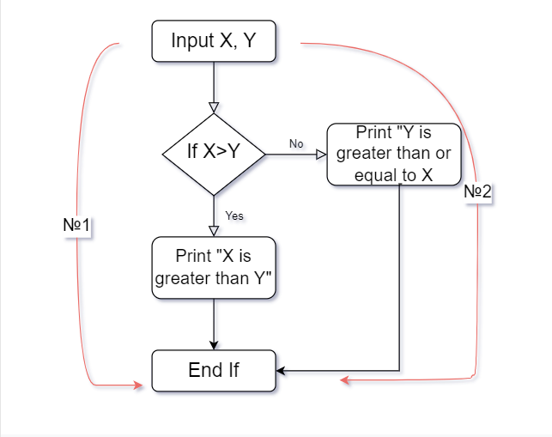

A minimum number of test cases is required to guarantee 100%

statement coverage - 2, 100% decision coverage - 2.

Answer: B. Statement coverage = 2, Decision coverage = 2

**Task 2**

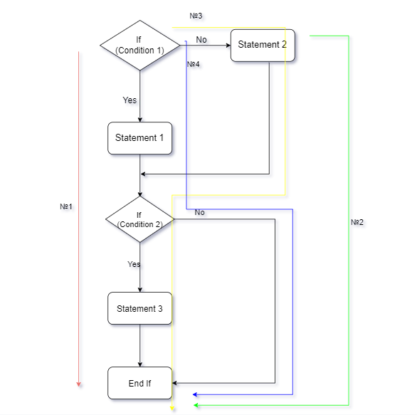

A minimum number of test cases is required to guarantee 100%

path coverage (path coverage) - 4

Answer: D. No answer is correct

**Task 3**

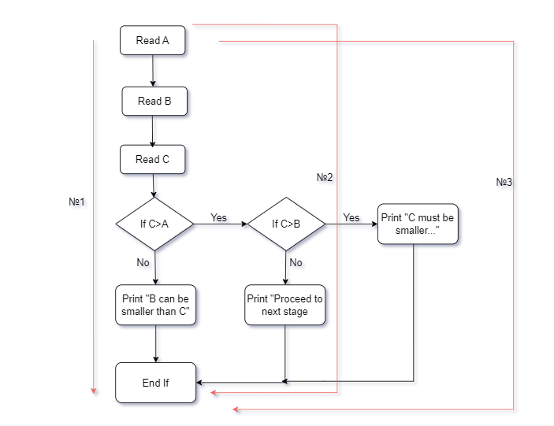

A minimum number of test cases is required to guarantee 100%

statement - 3, 100% decision coverage - 3.

Answer: C. 3, 3

**Task 4**

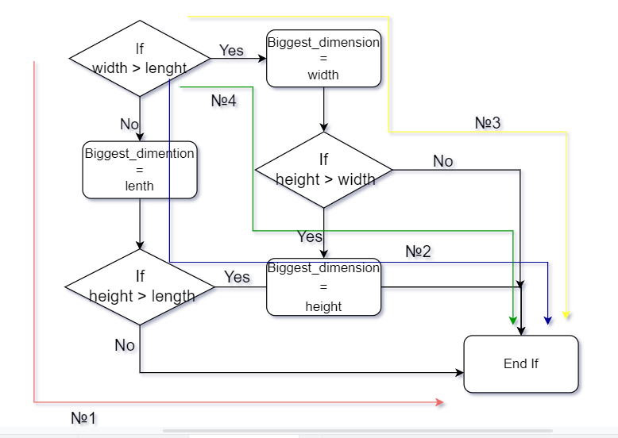

A minimum number of test cases is required to guarantee 100%

decision coverage - 4

Answer: B. 4

**Task 5**

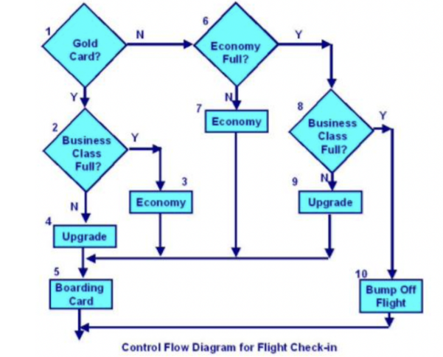

When starting Test 1 (Gold card holder upgraded to business class), the following operators are covered: 1, 2, 4, 5.

When starting Test 2 (Passenger without gold card remains in economy class) - 1, 6, 7, 5.

When starting Test 3 (Passenger who was bumped off the flight) - 1, 6, 8, 10.

8 operators out of 10 are covered.

Statement Coverage = 8/10*100%= 80%

Answer: C. 80%